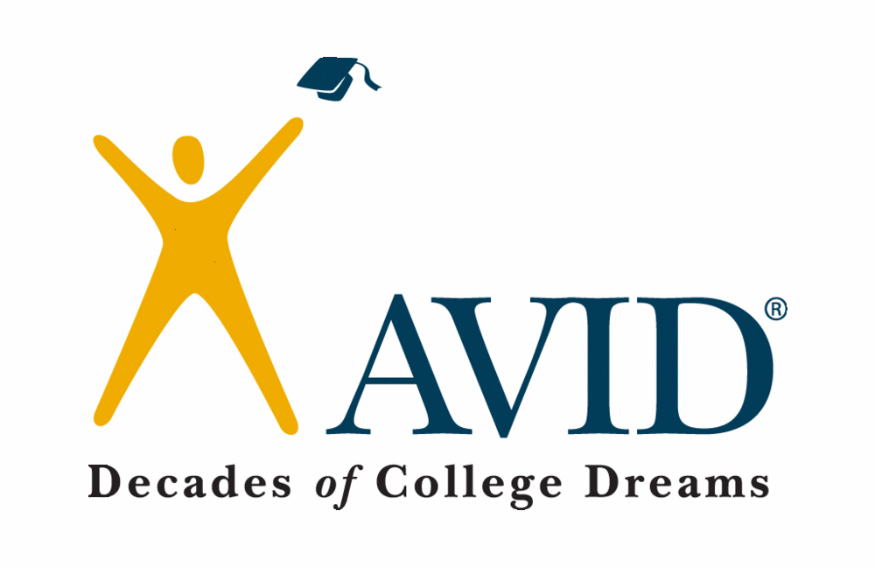

Are You…
- Interested in going to college?
- Tired of making average grades or not
reaching your full potential?
- Motivated to learn but not always
sure how to succeed?
- Ready to raise the bar and become a
top HONORS student?
- Desiring free tutoring during the school
day to assist you in classes?
- Desiring an elective with other students
who really want to be at school and learn?

Then AVID could
be for you!

Fill out the application and return it to
Mrs. Palermo by May 15th 2015

What AVID is…

The mission of AVID (Advancement Via Individual Determination) is to ensure that ALL students, especially those who find themselves “in the middle,” will succeed in rigorous curriculum, will complete a college prep path, and will become educated and responsible participants and leaders in society.

The AVID student…

- Makes As, Bs, and even an occasional C
- Has the desire to go to college
- Is willing to work hard
- Is capable of completing rigorous curriculum
- May fall short of his/her potential
- Is in need of acceleration, not remediation
- Practices good citizenship
- Has good attendance
- Earns average to high test scores
- Maintains a 2.5 or higher GPA
- Takes notes in all classes
- Is on-track
- Studies with a purpose daily

The AVID application process…

- Fill out the application completely and neatly in pen. Typing the responses is also acceptable.
- Ask two teachers to fill out the recommendation AND follow up by giving a Thank You note to each one.
- Turn in completed application to Mrs. Palermo @GMS by Friday, May 1st.
- Be ready for an interview with the school’s AVID Site Team if they have questions about your application.

For more information, contact Amanda Palermo, GMS AVID Coordinator,
apalermo@pasco.k12.fl.us 727-774-8000
Gulf Middle School
AVID Application
For the 2015-2016 School Year

Please complete neatly in ink.
Student Name
Current Grade
Parent/Guardian Name
Address
Home Phone | ( )- -
Cell Phone | ( )- -
Parent Email
Student Email

What is the highest level of education of:
Your Father
Your Mother

Grades | Math | Sci | SS | LA | Elec. | Elec. | Comments
Current
Last Qtr.
# of Missing Assignments

How do you overcome academic challenges?

In your opinion, what is the most difficult aspect of school?

What are your goals for middle school, high school, and after?

What activities are you involved in at school and/or in the community?

Use the 1-4 scale (where 1 is not important and 4 is extremely important) to rate the following with how YOU feel and how you think your family feels.
Question | You | Your Family
How important is it for you to go to a 4-year college? | 1 2 3 4 | 1 2 3 4
How important is it to complete all of your class assignments? | 1 2 3 4 | 1 2 3 4
How important is it to make straight As? | 1 2 3 4 | 1 2 3 4
How important is it to get into the AVID program? | 1 2 3 4 | 1 2 3 4

Personal Statement
Use the space below and the next page (or attach a document) to describe yourself. Think about the following questions as you write. What makes you unique? What kind of learner/student are you? Why would you like to be considered for AVID at Gulf Middle? Make sure you edit and have someone proofread before final submission.

You’re child is applying for the AVID program at GMS. Parent involvement and support are vital parts of success in the program. For more information about the program, contact Mrs. Palermo at GMS. Please take a moment to complete this form and return to the student in a sealed envelope OR email the completed form to apalermo@pasco.k12.fl.us . Completed applications are due to Gulf Middle School by May 1st .
AVID Parent Recommendation

Please rate you’re child to the best of your knowledge. Keep in mind, an AVID student may have struggles/weaknesses that make him/her an ideal candidate.

Attribute | Poor | Fair | Good
Ability to handle obstacles
Attendance
Punctuality
Voluntary participation
Peer relationships
Time management
Organization
Overall personal motivation

Additional comments about character, work habits, home life, background, leadership, need for AVID…

By signing below, I give permission for my student to apply for AVID and understand my role is to fully support him/her by being as involved as possible in my student’s education.

Parent Signature ____________________________________________

By signing below, I understand my responsibilities should I be chosen as an AVID student. I am fully committed to working hard and preparing myself for college.

Student Signature ___________________________________________

The following student is applying for the AVID program. Teacher recommendations are a vital part of successful placement. Please take a moment to complete this form and return to the student in a sealed envelope OR email the completed form to apalermo@pasco.k12.fl.us . Completed applications are due to Gulf Middle School by May 1st . Thank you in advance for your help.
AVID Teacher Recommendation

Student Name _______________________ Current Class Grade ______

Teacher ____________________________ Date ____________________

What AVID is…
- A research-based program that assists motivated students and provides them with support and tutoring to enable them to succeed in advanced classes
- An in-school academic class that prepares students for college
What AVID isn’t…
- A remedial program
- A free ride

Please rate the student to the best of your knowledge. Keep in mind, an AVID student may have struggles/weaknesses that make him/her an ideal candidate.

Attribute | Poor | Fair | Good | Top  10% | No Basis for Judgment
Personal character
Ability to handle obstacles
Attendance
Punctuality
Voluntary participation
Peer relationships
Time management
Organization
Overall personal motivation

Additional comments about character, work habits, home life, background, leadership, need for AVID…

Is the student currently in an advanced class capable of being in an advanced class next year, or
unlikely to succeed in an advanced class?
Which content area(s) could he/she take advanced in? _______________

Teacher Signature ___________________________________________ Date ________________
The following student is applying for the AVID program. Teacher recommendations are a vital part of successful placement. Please take a moment to complete this form and return to the student in a sealed envelope OR email the completed form to apalermo@pasco.k12.fl.us . Completed applications are due to Gulf Middle School by May 1st . Thank you in advance for your help.
AVID Teacher Recommendation

Student Name _______________________ Current Class Grade ______

Teacher ____________________________ Date ____________________

What AVID is…
- A research-based program that assists motivated students and provides them with support and tutoring to enable them to succeed in advanced classes
- An in-school academic class that prepares students for college
What AVID isn’t…
- A remedial program
- A free ride

Please rate the student to the best of your knowledge. Keep in mind, an AVID student may have struggles/weaknesses that make him/her an ideal candidate.

Attribute | Poor | Fair | Good | Top  10% | No Basis for Judgment
Personal character
Ability to handle obstacles
Attendance
Punctuality
Voluntary participation
Peer relationships
Time management
Organization
Overall personal motivation

Additional comments about character, work habits, home life, background, leadership, need for AVID…

Is the student currently in an advanced class capable of being in an advanced class next year, or
unlikely to succeed in an advanced class?
Which content area(s) could he/she take advanced in? _______________

Teacher Signature ___________________________________________ Date ________________

